**Steps for creating and collecting data in ArcGIS Field Maps**

**1) Create the feature layer and map in ArcGIS Online**

Navigate to ArcGIS Online, log in, and select the “New Item” button on the content page

Screenshot of the ArcGIS content tab highlighting the "new item" button in the top left of the screen


Once opened, choose the “Feature layer” option

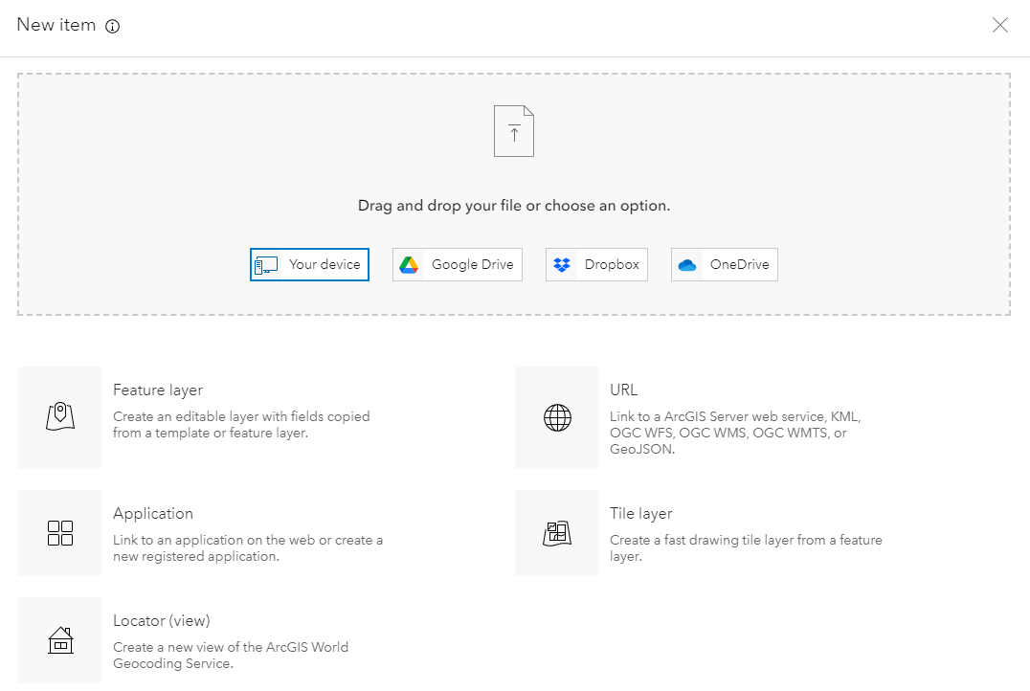

Choose “Create a blank layer”. You can also use a template created by Esri for Field Maps, which have pre-set fields and layers and are created for more specific scenarios like water quality monitoring or fire hydrant maintenance.

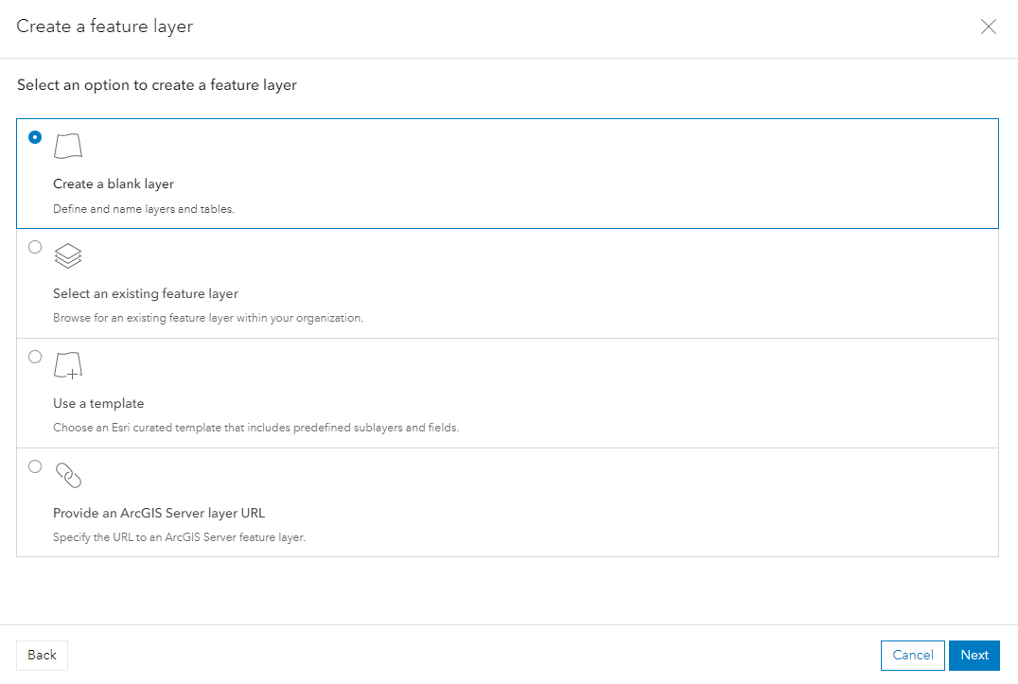

Create however many layers you need for data collection as well as the data type. This example is going to be collecting bike rack locations across campus, so I chose one point layer. To add GPS data collection to your data points, select the “Add GPS metadata fields” option.

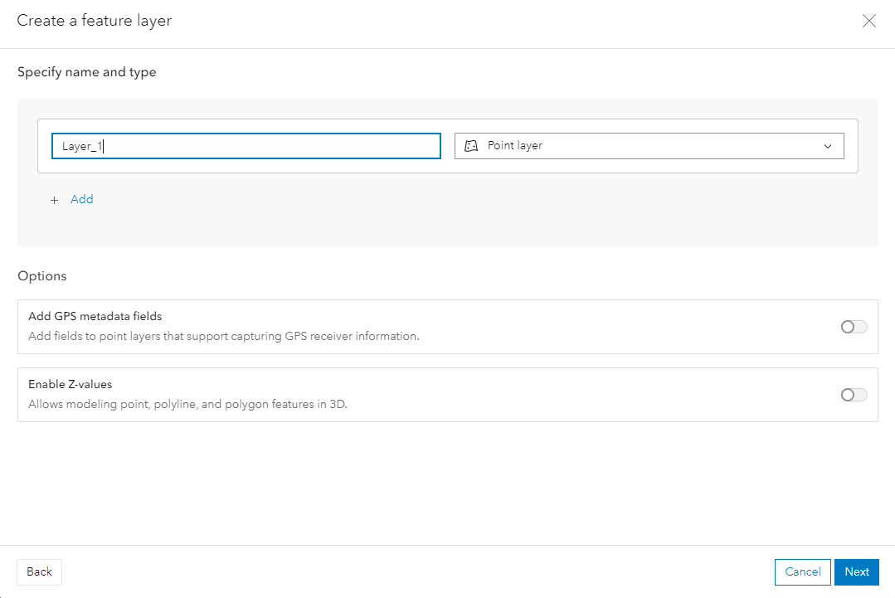

After naming and saving the feature layer, access the feature layers page and go to the “Data” section. To add a field for data collection, select the menu bar on the left (the three lines) and choose “Add field”

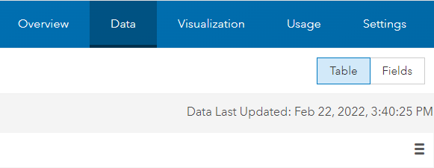

Create the field that you want to collect data for. In this example, I created a field that lets you record how many bikes there are at an observed bike rack. I also created a field to record the maximum number of bike slots available.

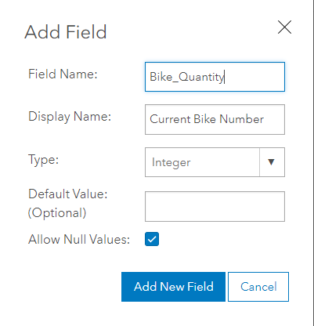

Save the field information and navigate to the Setting tab. Verify the enable editing is checked.

Create a new map by accessing the “Map” in the upper bar. The sidebar on the left will allow you to add layers to the map: click “Add layer’ and select the feature layer you just created.

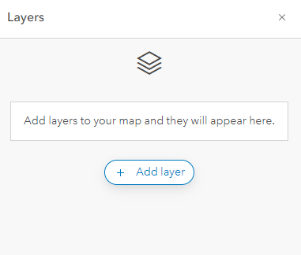

While there is no data yet, you can now choose to create the symbology for the field points you will be collecting. This can also be done after the points are collected, and the field points will just be given the default symbology until you choose to edit them. For this example, I chose a biking symbol.

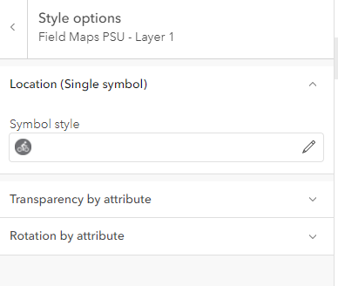

Save and name the map with the feature layer: this is the end of step one, and we will now be collecting data within the Field Maps app

**2) Collect data in Field Maps App**

Download and open the ArcGIS Field Maps app from the app store. The first step is signing in with your ArcGIS Online account. While you can skip signing in, it is required to use the map you just created in ArcGIS Online.

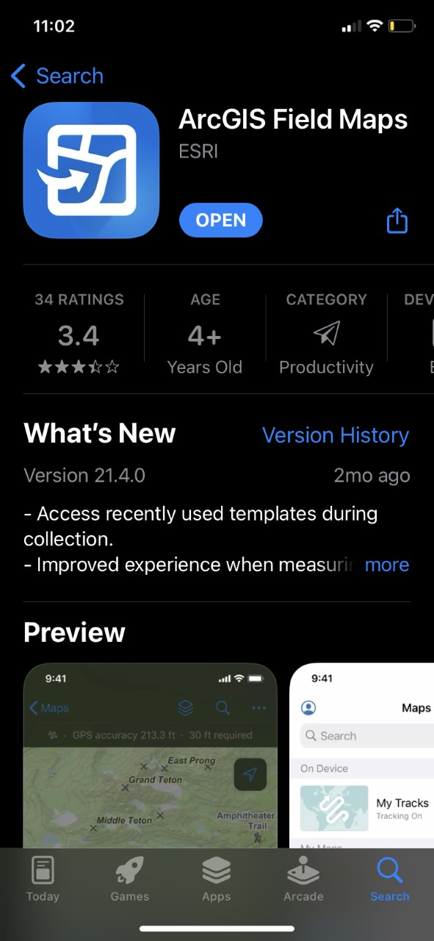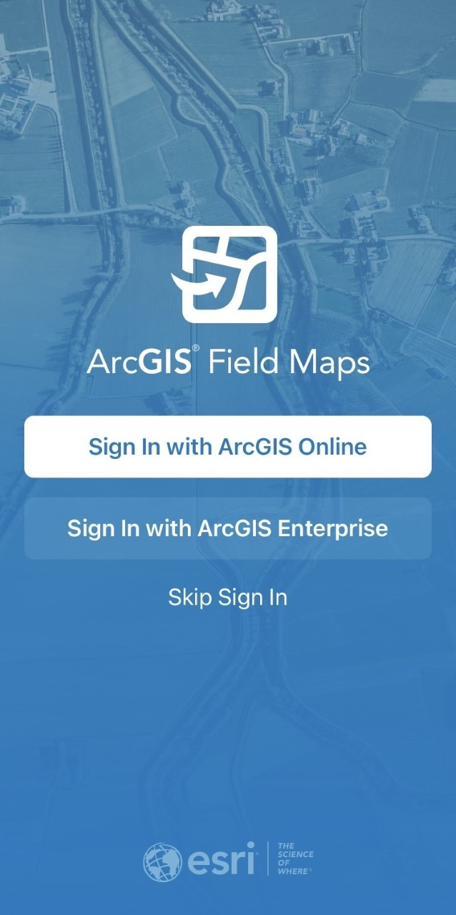

From the home page, find and select the web map you just created.

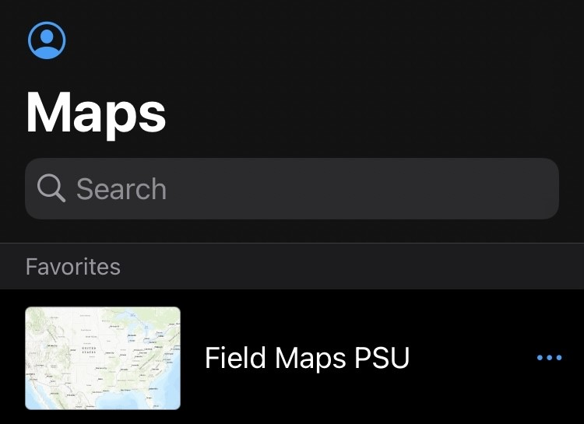

Once the map is opened, you should be able to find your current location as well as navigate around the map. Once you are ready to collect a field point, click the blue “+” button on the bottom right of the screen.

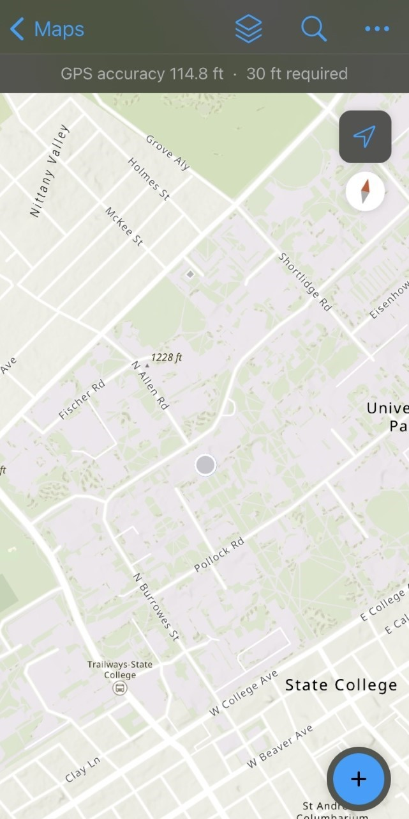

Once you click “Add Point” you will be able to record data within the fields you created earlier. You can also take a picture of the data you are collecting and add any necessary attachments. Once you are done filling out the fields, hit the “Submit” button.

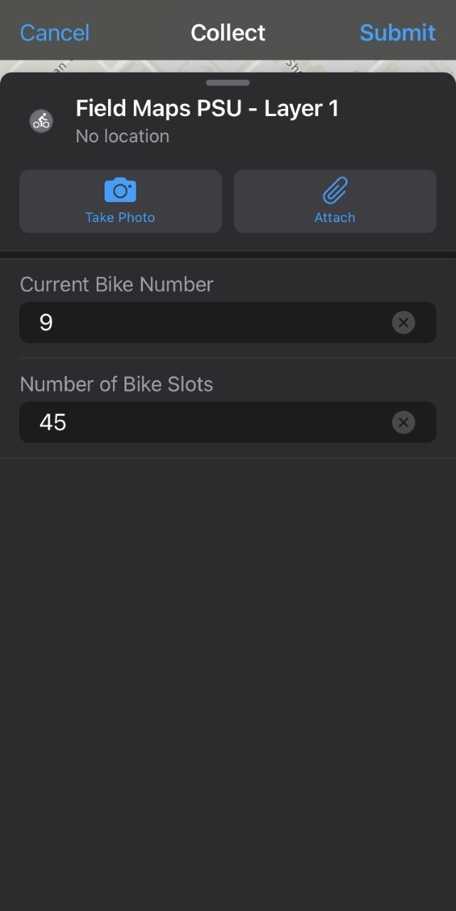

The data point you submitted will now appear on the map along with the attribute data you added to it. Repeat this process as you move about the field collecting data points. Data points can also be edited at any time.

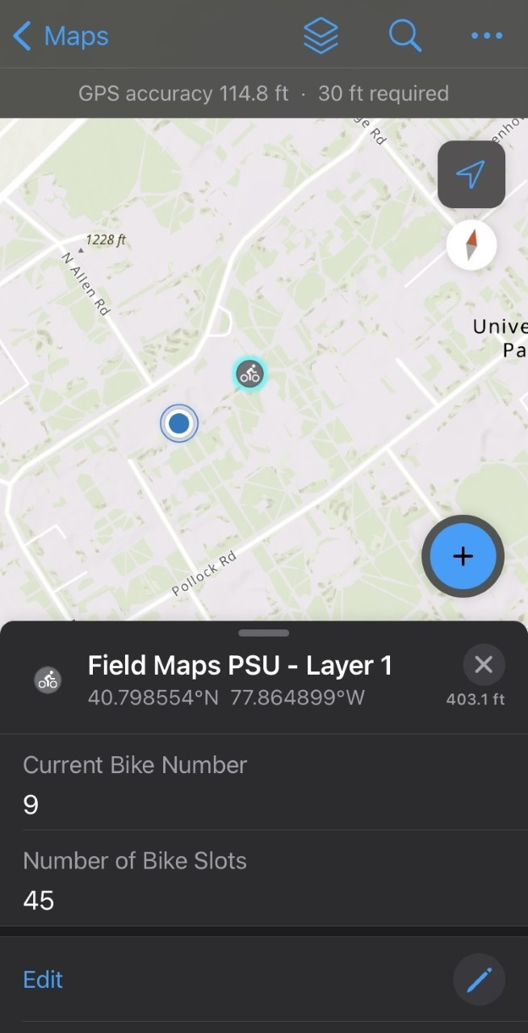

Additional features that you can use in Field Maps are highlighted at the end of the tutorial.

**3) View and analyze data in ArcGIS Online**

Navigate back to the map you created in ArcGIS Online. Both reopening the web map or refreshing it should automatically load the data points you collected on the field. You may now view the table for this data and analyze it as well as change the symbology however needed.

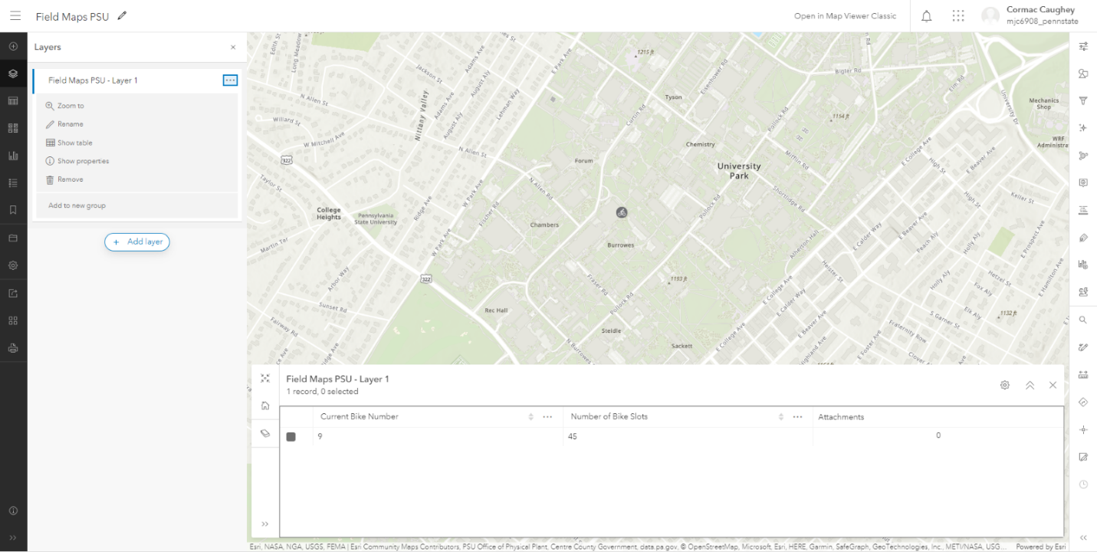

**Additional features in the Field Maps app**

There are several other features within the Field Maps app that can come in handy while collecting data.

Selecting the three dots in the upper right corner of the screen will open several other viewing and editing options

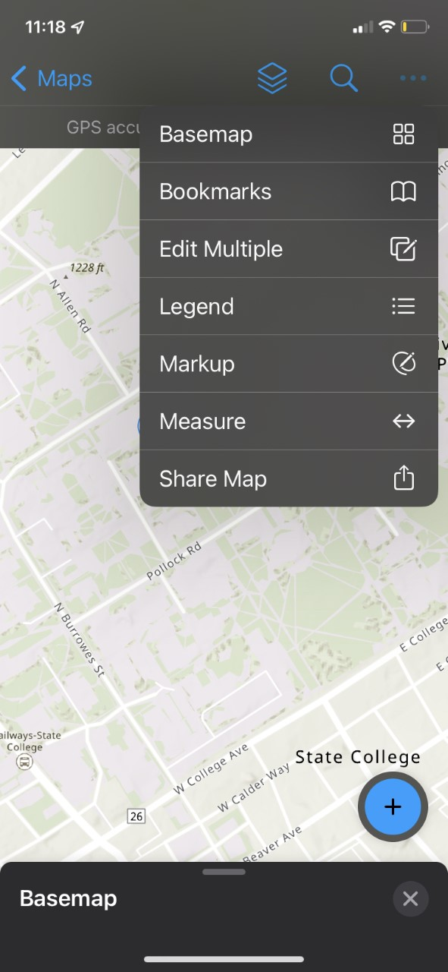

One of these options is basemap toggle: this will allow you to view the map with several different basemaps, and can be helpful when needing to identify certain features like buildings or roads.

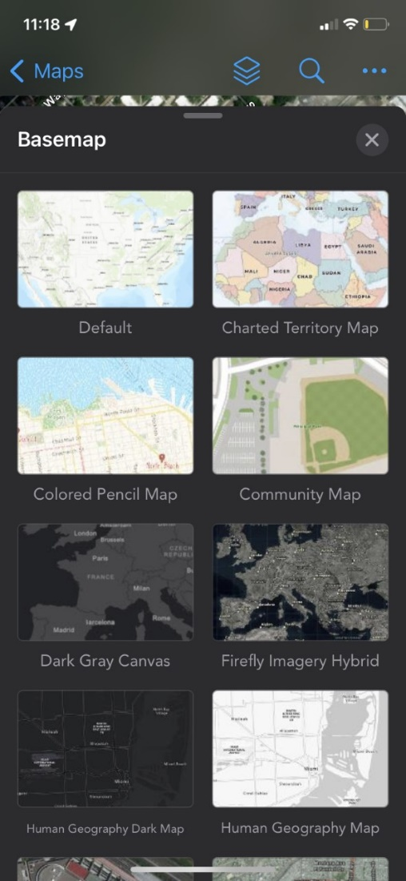

You can also use the measure tool to measure the distance between any points you select.

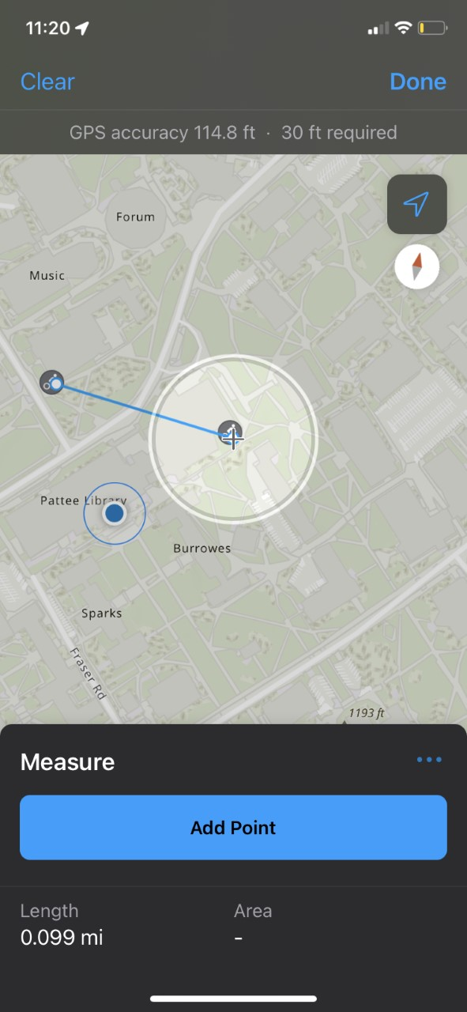

One final tool is markup, which allows you to “markup” the screen with any notes or additional information you need. With this, you can add additional points, draw lines, highlight certain data points, etc.

